Additional Exercises #5:

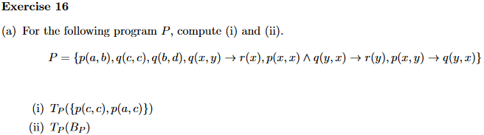

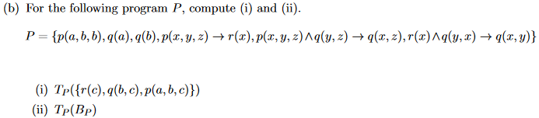





Tp(q(a,b), p(c)) = {q(a,b), p(c), r(b,a)}

Pre-fixed:

{q(a,b), p(c), r(b,a)}

{q(a,b), p(c), r(b,a), q(b,c), r(c,b)}

{q(a,b), p(c), r(b,a), q(b,t), r(t,b)}